LAB ASSIGNMENT

NAME – KAPAROTU VENKATA SURYA THARANI

COURSE – AIDE

USN ID – 22BTRAD018

Q –Create functions for push and pop operations of stack.

For push operation

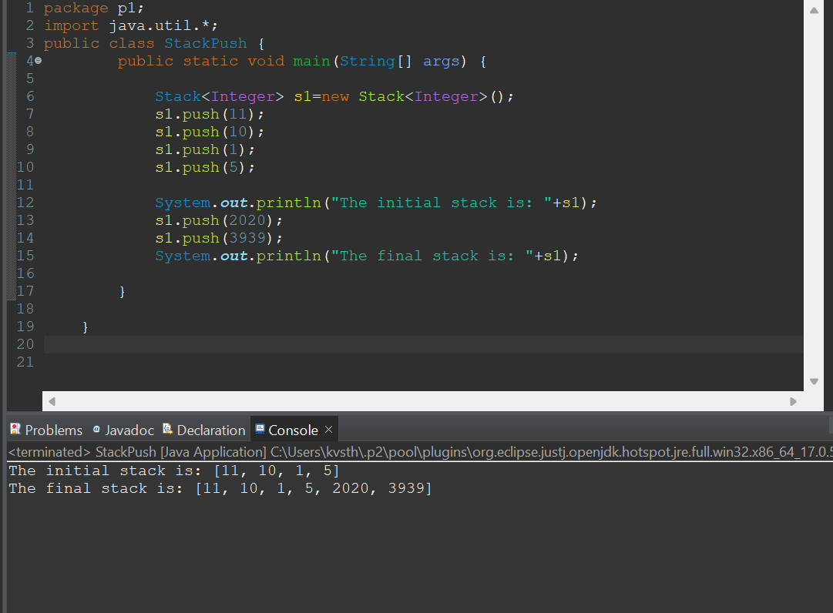

For pop operation

